4.Implementing primary key and foreign key constraints in database tables.
Create a Table and Use It
CREATE DATABASE IF NOT EXISTS school_db;
USE school_db;
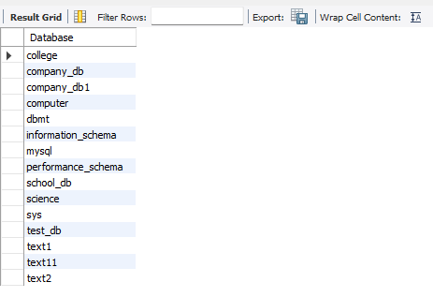

Create a table with a primary key
create table student(
student_id int auto_increment,
name varchar(100),
primary key(student_id)
);
Create Another Table with a Foreign Key
CREATE TABLE enrollments(
enrollment_id int auto_increment,
student_id int,
course_name varchar(100),
primary key(enrollment_id),
foreign key(student_id)references student(student_id)
);

show tables;

Insert Sample Data
insert into student(name)values('shravani'),('alas');
select*from student;
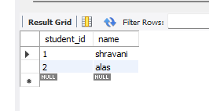

insert into enrollments1(student_id,course_name)values(1,'math'),(2,'science');
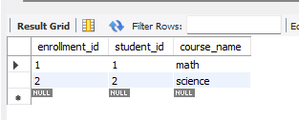
select*from enrollments1;

Test the Relationship
SELECT
s.name,
e.course_name
FROM
student s
JOIN
enrollments1 e ON s.student_id=e.student_id;



